**TO-Do List Project 2**

1.Created the Project Folder

* Created the Project Folder for the Project as TO-Do List.
* Added two folders Css and Js for styling.
* Added two files main.js and time.js in Js folder and two files corner.css and main.css in Css folder.
* Then Added index.html file.

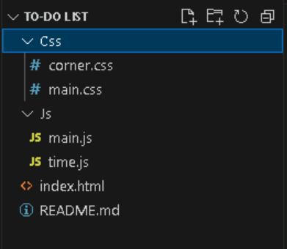

2.Styled the website using css

* Created the corner.css and main.css file to add styles for the webpage.
* Styled the header, sections, project List, and Footer for a professional look.

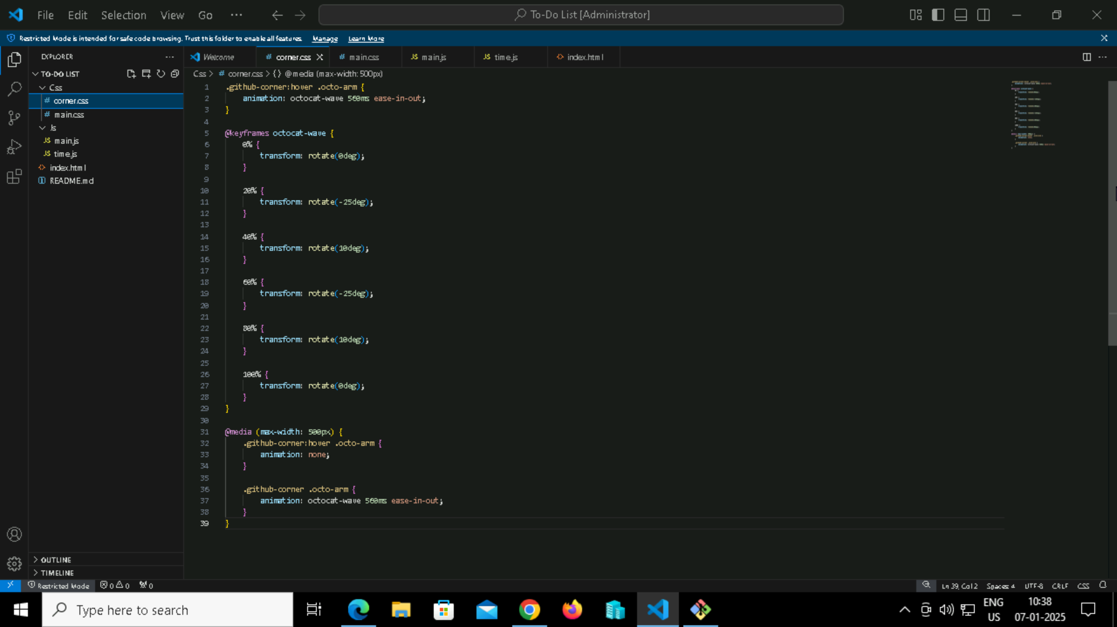

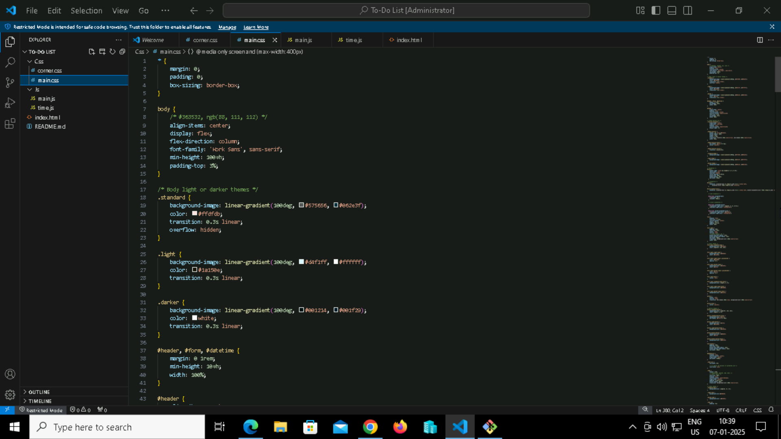

3.Styled the website using css

* Created the main.js and time.js file to add styles for the webpage.
* Styled the header, sections, project List, and Footer for a professional look.

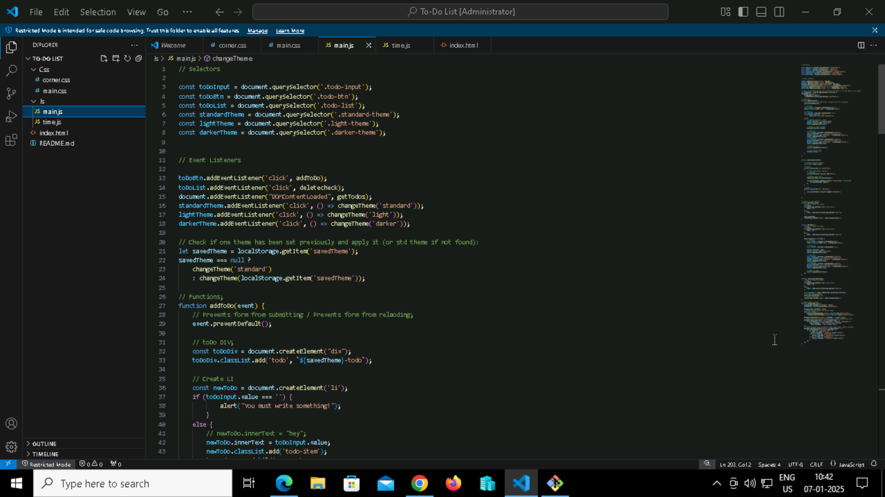

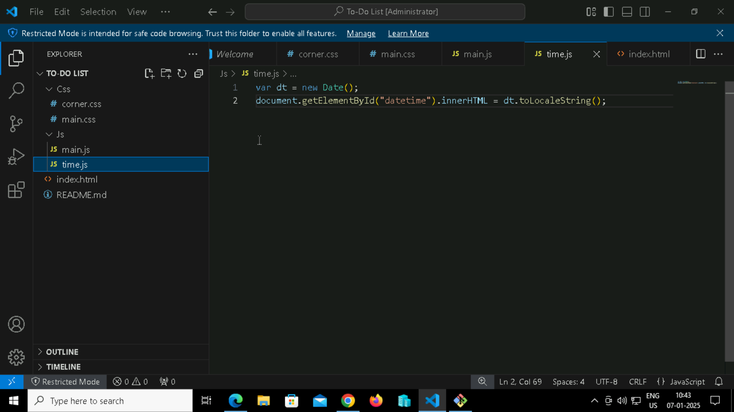

4.Designed the HTML Structure

* wrote the index.html file
* Used semantic HTML tags to structure the page.

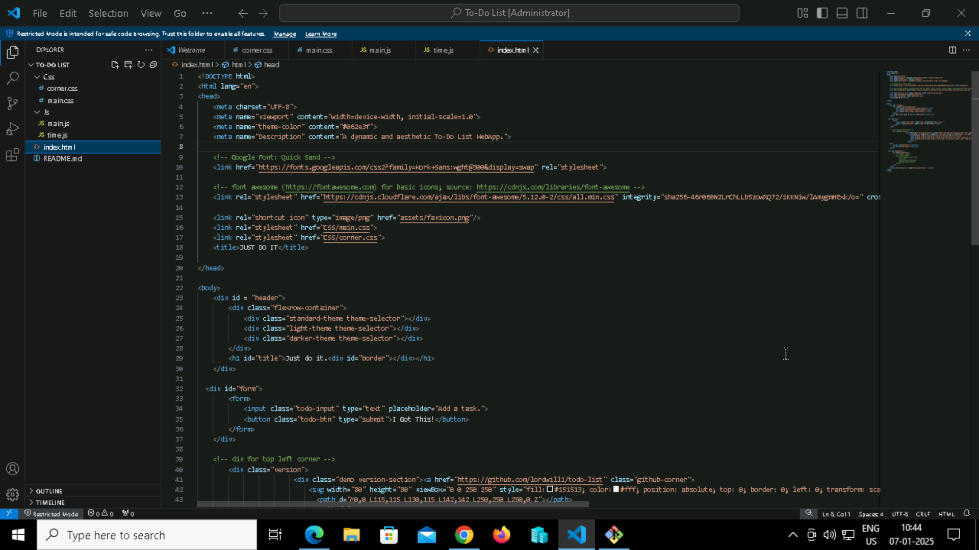

4. Previewed the Website Locally

* Opened the index.html file in a browser using VSCode's Live Server to check how it looks.
* Ensured the layout and styling matched the design plan.

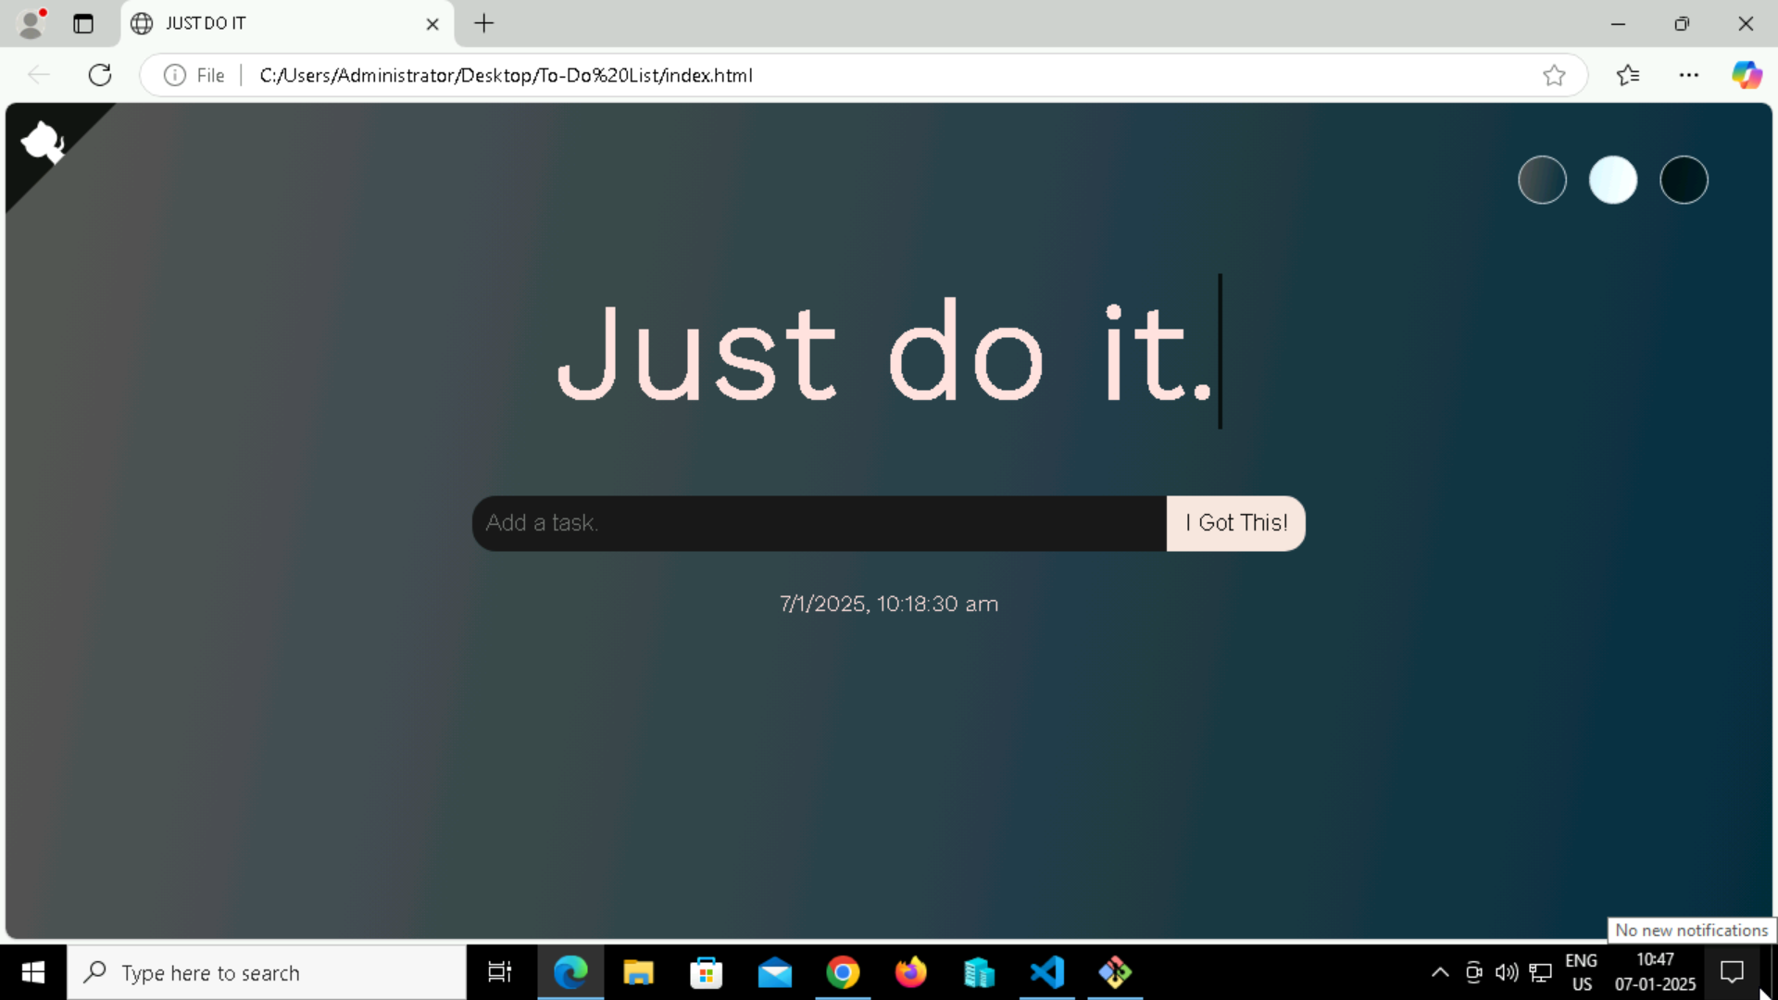

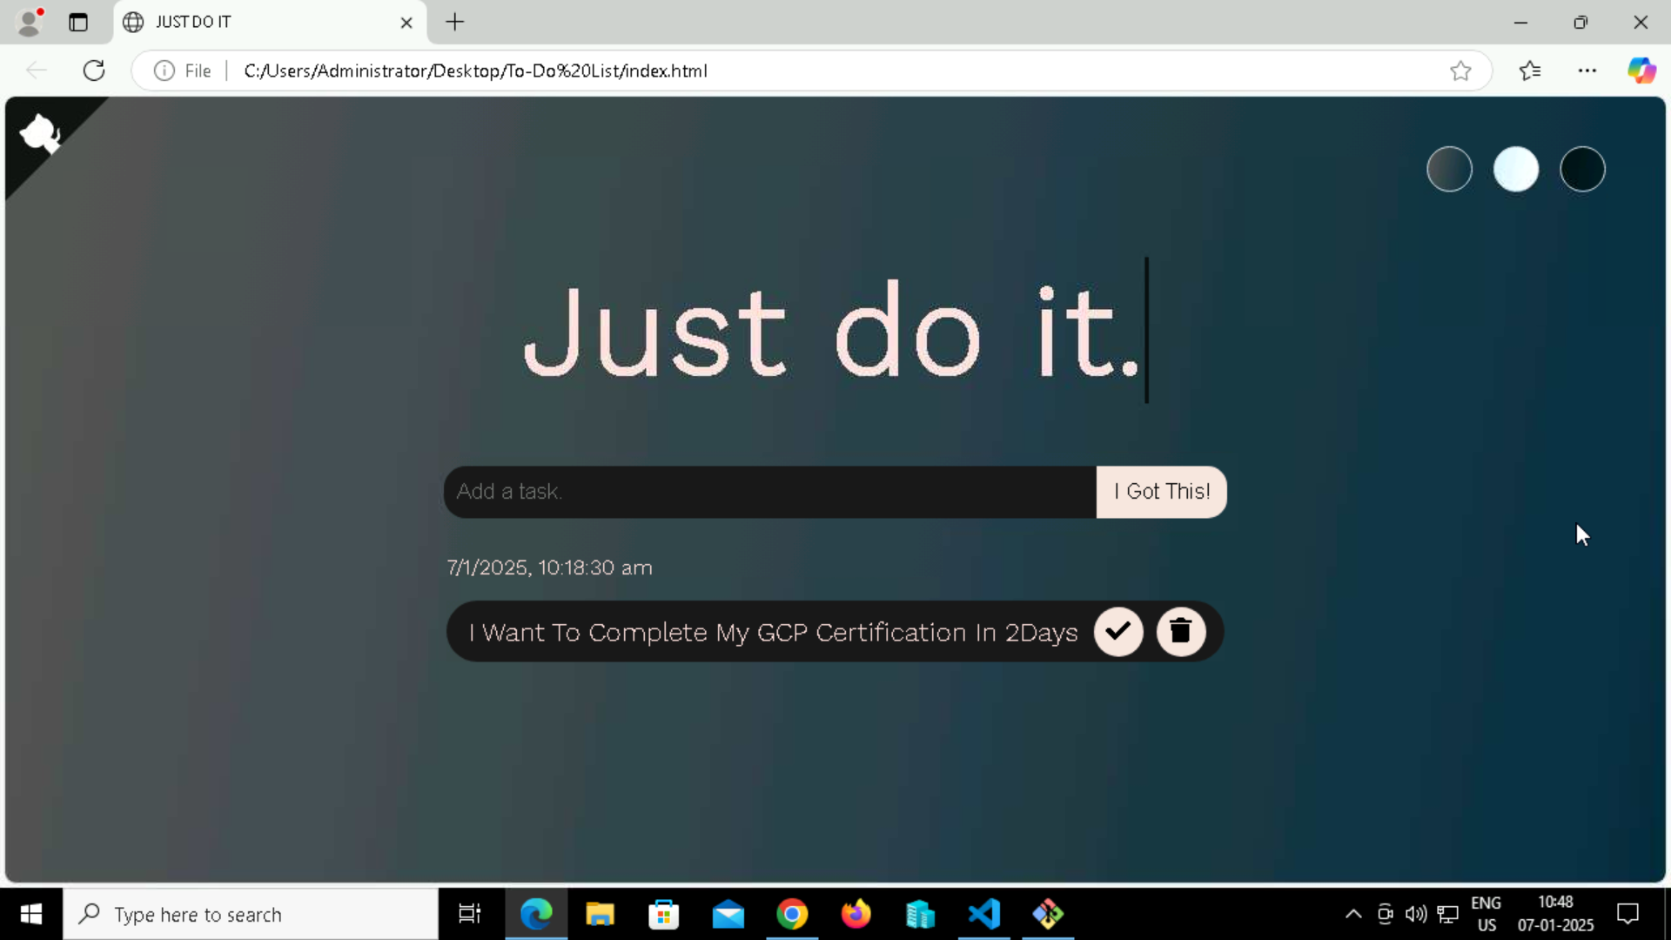

5. Initialized a Git Repository, Linked Local Repository to GitHub, pull files, add the files, commit the changes then push files.

* git init
* git remote add origin “https://github.com/Bhargavkulla/To-Do-List.git
* git pull origin main
* git add
* git status
* git commit -m “files added”
* git branch -m master main
* git push origin main

